**DAILY ONLINE ACTIVITIES SUMMARY**

|  |  |  |  |  |  |  |  |  |
| --- | --- | --- | --- | --- | --- | --- | --- | --- |
| **Date:** | **11/06/2020** | | | | | **Name:** | **PRANEETA P HANDRAL** | |
| **Sem & Sec** | **4thSEM. & ‘B’ SEC.** | | | | | **USN:** | **4AL19CS401** | |
| **Online Test Summary** | | | | | | | | |
| **Subject** | | **_ _ _** | | | | | | |
| **Max. Marks** | | **30** | | **Score** | | | **_ _** | |
| **Certification Course Summary** | | | | | | | | |
| **Course** | **Introduction to Cyber security** | | | | | | | |
| **Certificate Provider** | | | **Greatlearning Academy** | | **Duration** | | | **5 Hrs.** |
| **Coding Challenges** | | | | | | | | |
| **Problem Statement:** Write a Java Program to Segregate Even and Odd numbers.  Given an array A[], write a function that segregates even and odd numbers. The functions should put all even numbers first, and then odd numbers.  Example:  Input = {12, 34, 45, 9, 8, 90, 3}  Output = {12, 34, 8, 90, 45, 9, 3} | | | | | | | | |
| **Status: Executed.** | | | | | | | | |
| **Uploaded the report in Github** | | | | | **Yes** | | | |
| **If yes Repository name** | | | | | **LockdownCoding**  <https://github.com/praneetahandral/lockdowncoding> | | | |
| **Uploaded the report in slack** | | | | | **Yes** | | | |

**Online Certification Course Summary**: I have taken my Online Certification Course in **Great learning academy** the course which I have opted is **Introduction to Cyber security**. Course contains videos, tutorials, assessments and quiz. Today I have learn about **Introduction to Cryptography** and **What Is Cybersecurity.**

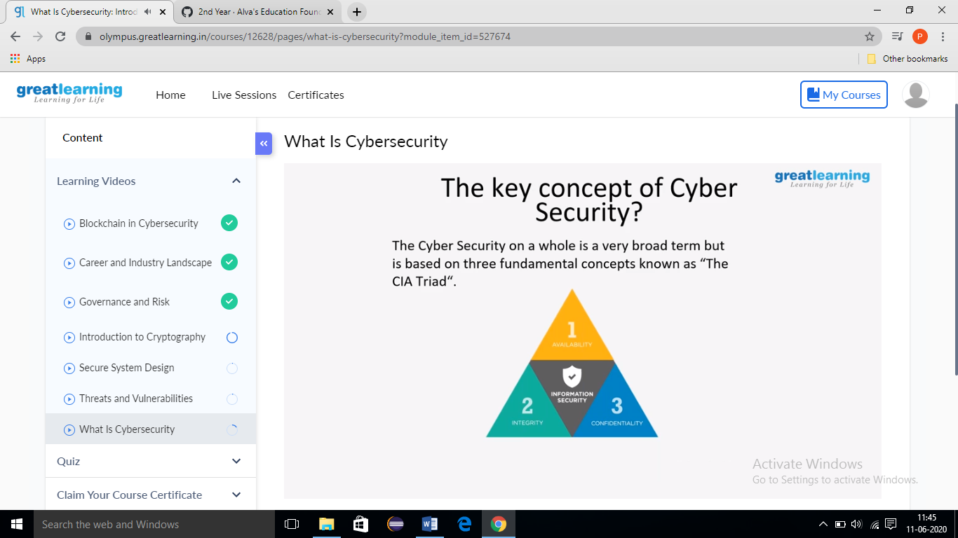

**Online Coding Summary: Today I received one program from Prof.** **shilpa CSE Dept. The program is mentioned above. to my GitHub repository and I’ve shared the snapshot below.**

